**KMS Sql Case Study Analysis**

**This Sql Query Analysis analyses Kultra Mega Stores (KMS) data and presents key insights and findings that will help KMS thrive, offer better product services and optimize cost and performance**.

We will be working with two Tables for our Analyses; **order_status** and **Kms sql case study**

**QUESTION 1. Which product category had the highest sales?**

Technology is the Product category with the highest sales

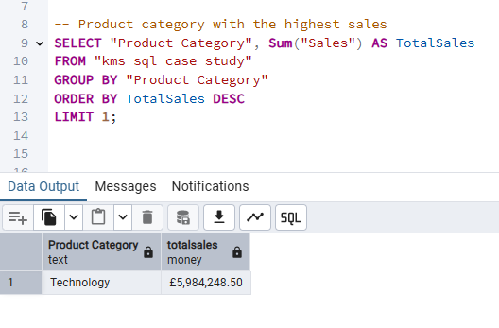

**QUESTION 2. What are the Top 3 and Bottom 3 regions in terms of sales?**

The Top 3 Regions by Sales are West, Ontario and Prarie

The Bottom 3 is Nunavut, Northwest Territories and Yukon.

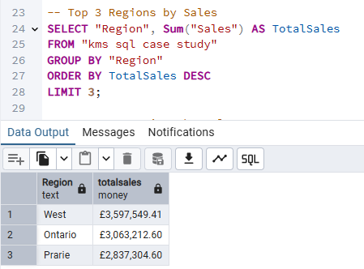

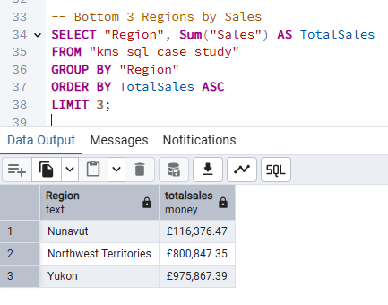

**QUESTION 3. What were the total sales of appliances in Ontario?**

**The total sales of appliances in Ontario is 202,346.84**

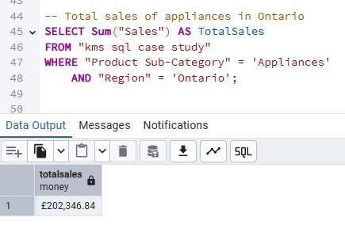

**QUESTION 4. Advise the management of KMS on what to do to increase the revenue from the bottom 10 customers**

**Step 1: Identify the Bottom 10 Customers**

We first need to find the customers who contributed the **least total sales**.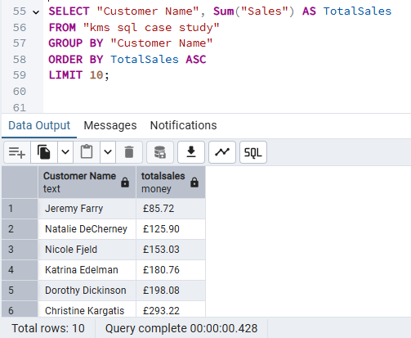

**Step 2: What segments do these customers belong to?**

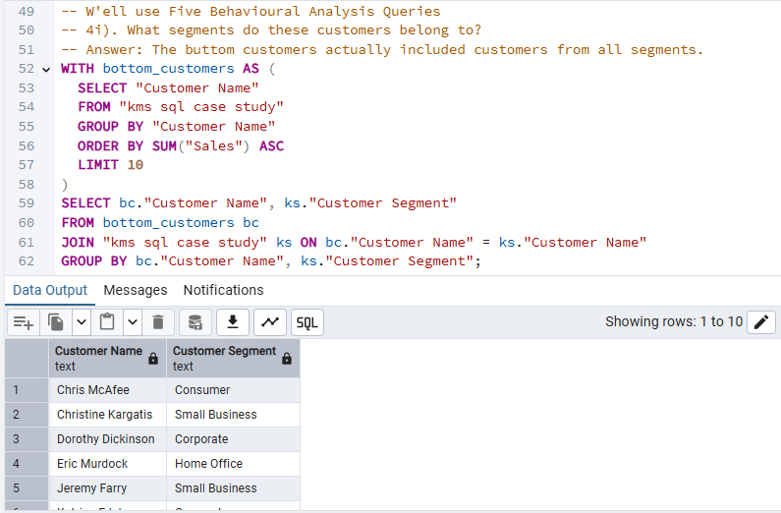

**Step 3: What product categories are they buying?**

These customers tend to purchase low-ticket items or focus only on a narrow category like Office Supplies, avoiding higher-margin categories like Technology or Furniture

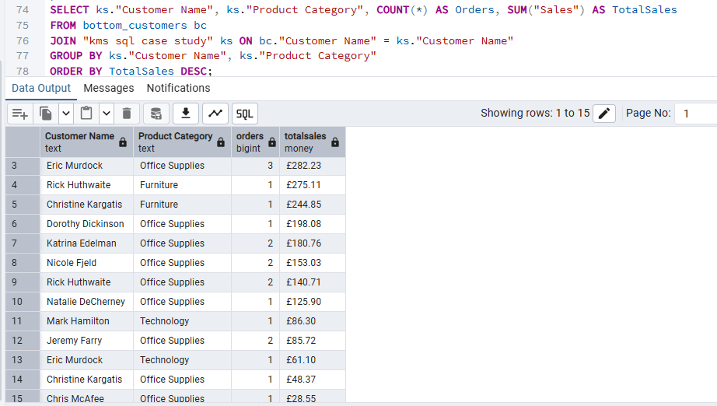

**Step 4: How many orders did they place?**

The total number of orders by these customers is low, which directly impacts their overall sales contribution.

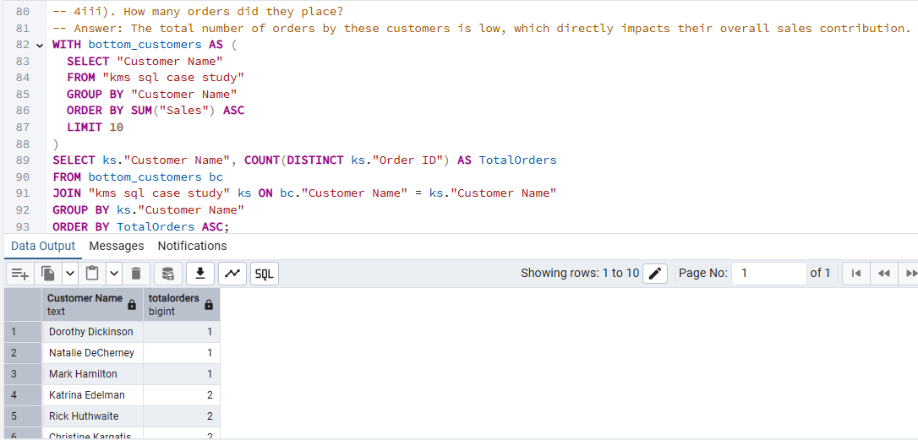

**Step 5: What shipping modes do they prefer?**

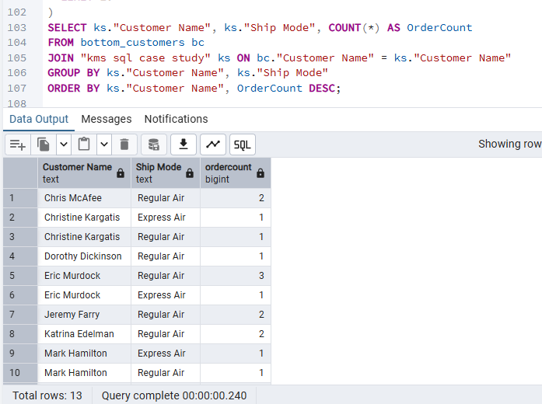

**Step 6: Do they buy discounted products?**

**They often rely on discounted products, resulting in reduced revenue and possibly lower profits.**

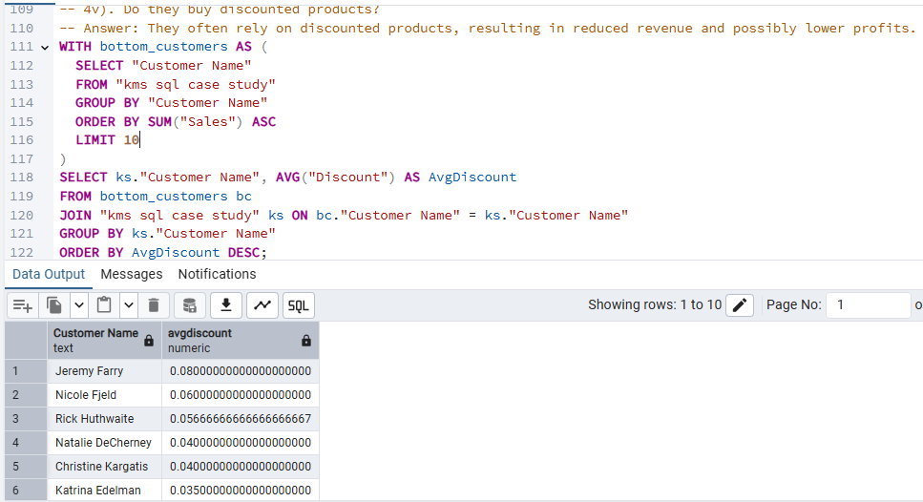

**ADVISE:**

**Promote Product Recommendations with Faster Shipping**

Bundle products with Regular Air shipping promotions.

Highlight how certain products are “eligible for fast delivery” to encourage upselling.

**Targeted Upselling & Cross-selling Campaigns**

Recommend higher-margin or complementary products.

Bundle commonly purchased items with mid- or high-value products.

**Incentivize More Frequent Purchases**

Offer loyalty points or free shipping after a certain number of purchases.

Introduce subscription models or reorder reminders for regularly bought items.

**QUESTION 5. KMS incurred the most shipping cost using which shipping method?**

**Delivery Truck incurred the most shipping cost.**

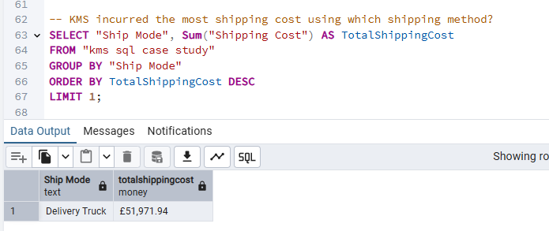

**QUESTION 6. Who are the most valuable customers, and what products or services do they typically purchase?**

**The most valuable customers mostly purchased Copiers and Fax and the preferred ship method for these valuable customers were mostly Regular Air, with Delivery Truck being the next**

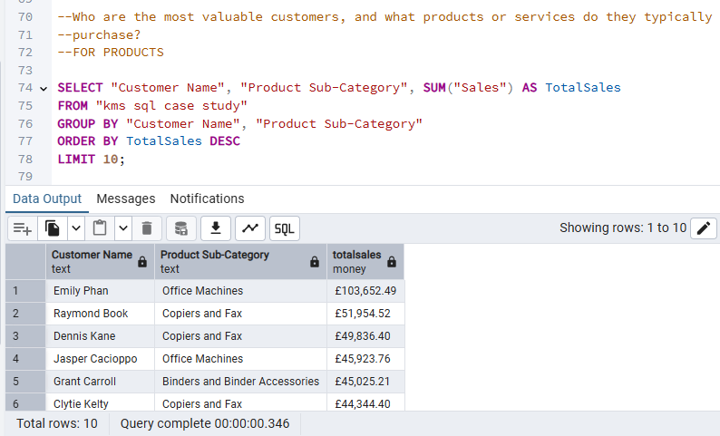

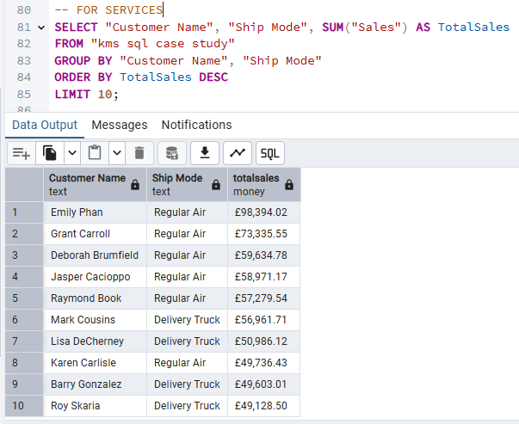

**QUESTION 7. Which small business customer had the highest sales?**

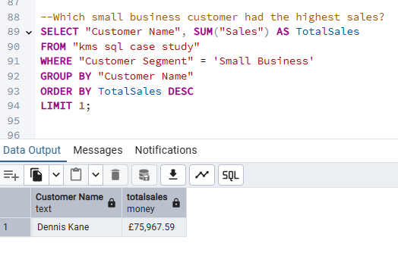

**QUESTION 8. Which Corporate Customer placed the most number of orders in 2009 – 2012?**

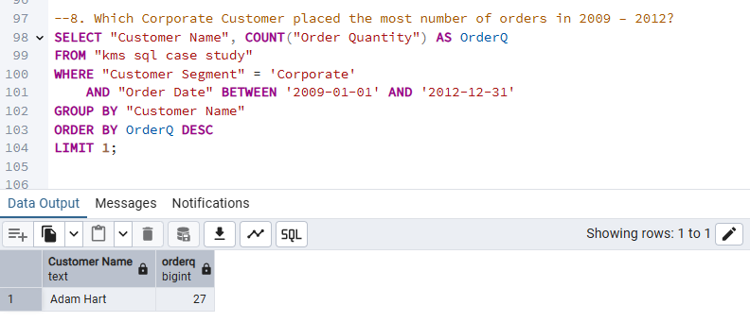

**QUESTION 9. Which consumer customer was the most profitable one?**

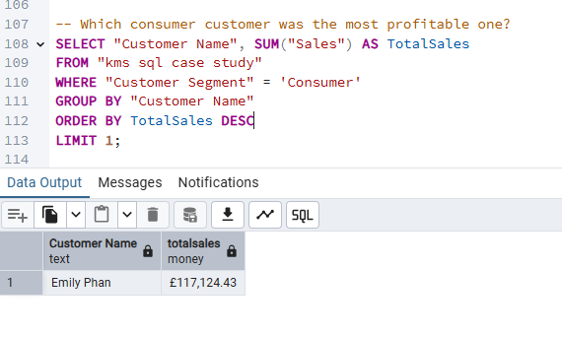

**QUESTION 10. Which customer returned items, and what segment do they belong to?**

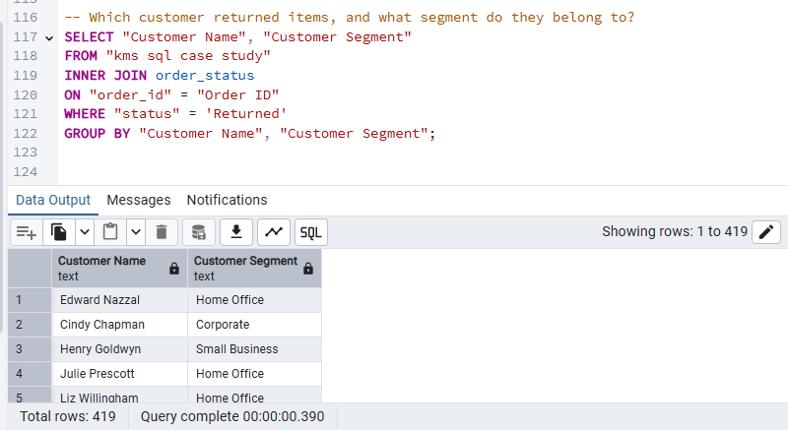

**QUESTION 11. If the delivery truck is the most economical but the slowest shipping method and Express Air is the fastest but the most expensive one, do you think the company appropriately spent shipping costs based on the Order Priority? Explain your answer.**

**Query to find which shipping method incurred the most shipping cost**:

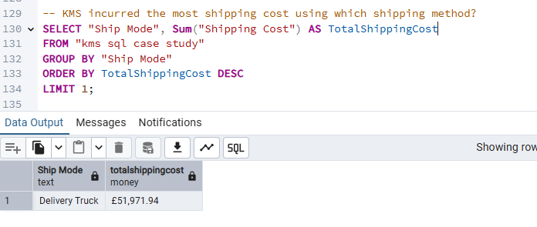

**Delivery Truck** incurred the **highest total shipping cost**.

Even though Delivery Truck is typically seen as the most economical option, it's possible that:

* It's used for a large number of orders, hence higher total cost.
* Or it's used inefficiently for non-low-priority orders.

Query to know **whether Delivery Truck was mostly used for** Low **priority orders**

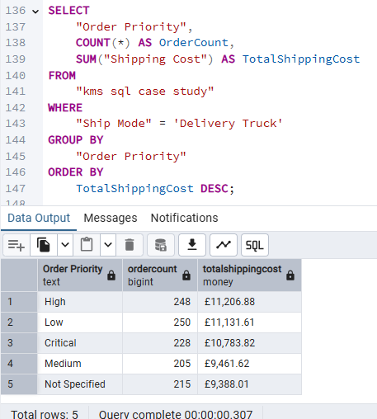

Low priority orders had the highest count (250) – this is expected.

However, "High" priority orders are almost just as many (248), and they incurred the highest shipping cost.

**Is Delivery Truck Really the Most Economical?**

**Delivery Truck had the highest total shipping cost** among all ship modes.

Yet it’s commonly perceived as the most economical.

But **total cost doesn’t always mean expensive per unit** so let’s dig deeper by checking for the **Average shipping cost per order by shipping method**

**This matters because Delivery Truck may have been used more often**, inflating its total cost, but **on average**, it might still be cheaper **per order** than Express Air or Regular Air.

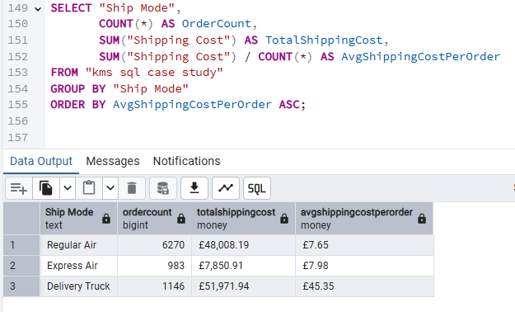

We define “economical” as **low cost per order**, so:

* **Regular Air (7.65)** is the cheapest.
* **Express Air (7.98)** is slightly more expensive.
* **Delivery Truck (45.35)** is **extremely expensive** per order.

**Regular Air is the most economical**.

### Then why do people think Delivery Truck is economical?

This could be due to **perception** or internal policy rather than actual cost analysis. Here are some possible explanations:

1. **Misconception** – People may assume trucks are cheaper due to "bulk delivery" ideas.
2. **Usage in bulk/large orders** – Maybe large or heavy items is assigned to Delivery Trucks regardless of cost.
3. **Internal policy** – Sometimes businesses prioritize trucks for certain types of shipments or locations without re-evaluating cost.

**ANSWER:**

**No**, KMS did not always spend shipping costs appropriately based on order priority.

Even though Delivery Truck is considered the slowest, it was heavily used for High and Critical priority orders.  
This suggests inefficient logistics — urgent orders should ideally use faster options, like Express Air.

### Suggested Recommendation:

KMS should:

* Reserve **Delivery Truck** for **Low and Medium** priority orders.
* Use **faster shipping modes** (e.g., Express Air) for **High and Critical** priority orders to align with urgency.
* Audit and optimize their logistics decisions to reduce **cost vs. service mismatch.**
* Although Delivery Truck is the most used method by cost, it is the least economical. KMS should reassess when and why trucks are chosen for delivery and consider shifting more deliveries to Regular Air, which is both cost-effective and used more efficiently.